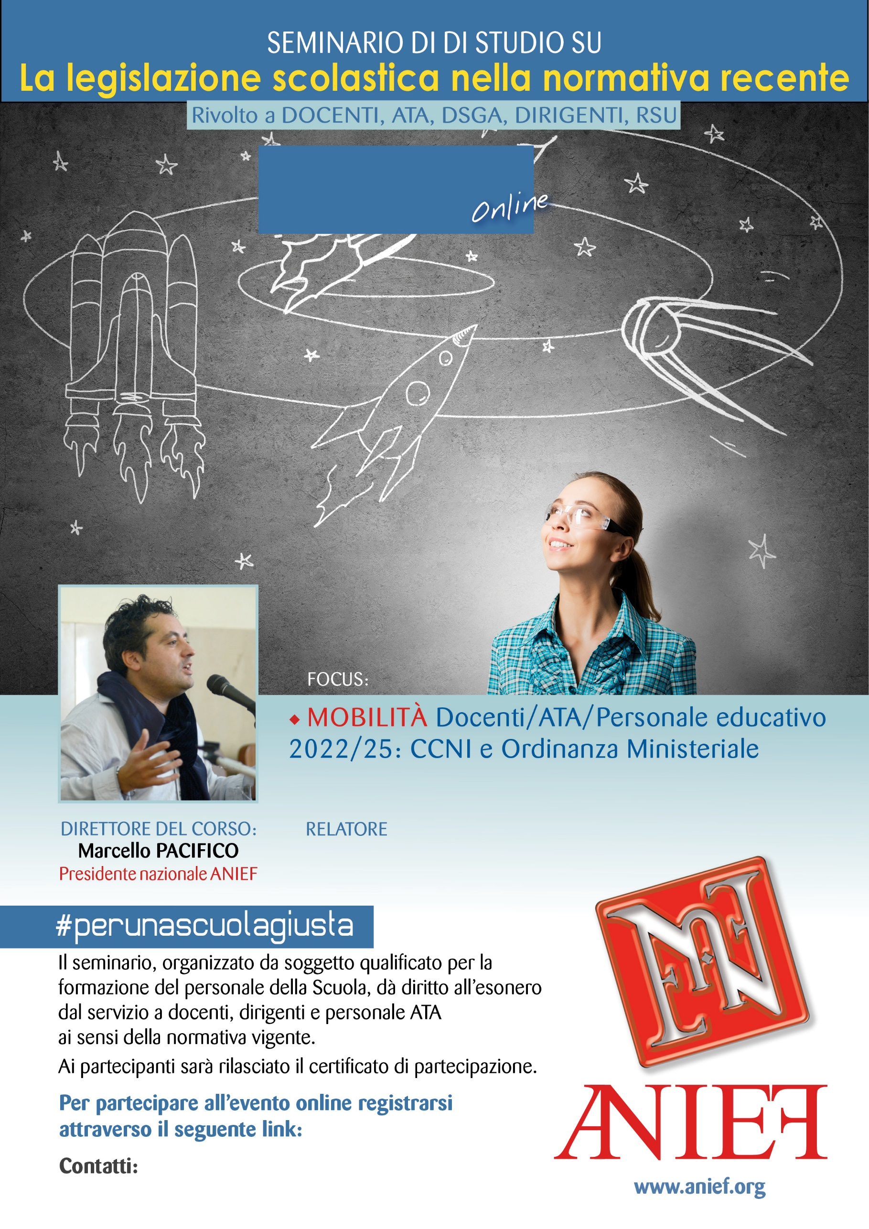

LINK DIRETTA: https://anief.org/as/UC9Z

torino@anief.net

MARCO GIORDANO

PIEMONTE - TORINO

08/03/2022 ORE 10:00 – 12:00